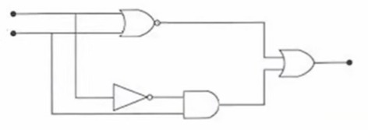

1. Para el circuito mostrado:
2. Identificar las entradas 🡪A, B
3. Identificar las compuertas🡪 NOR, NOT, AND, +
4. Obtener la tabla de verdad

|  |  |  |  |  |  |
| --- | --- | --- | --- | --- | --- |
| A | B | A +B | A’ | A’ .B | (A +B)’ |
| 1 | 1 | 1 | 0 | 0 | 0 |
| 1 | 0 | 1 | 0 | 0 | 0 |
| 0 | 1 | 1 | 1 | 1 | 0 |
| 0 | 0 | 0 | 1 | 0 | 1 |

Tabla resultante

|  |  |  |
| --- | --- | --- |
| A | B | X |
| 1 | 1 | 0 |
| 1 | 0 | 0 |
| 0 | 1 | 1 |
| 0 | 0 | 1 |

1. Representar el circuito en una ecuación

(A +B)’ +( A’ .B)

1. Validar la tabla de Verdad en la ecuación

* A=1 Y B=1

=(1 + 1)’ + ((1)’ . 1)

=1’ +(0 . 1)

= 0 +(0)

=0

* A=1, B=0

=(1 +0)’ +(1’ . 0)

=1’ +(0 . 0)

=0 +0

=0

* A=0 Y B=1

=(0 +1)’ +((0)’ . 1)

=1’ +(1 . 1)

=0 +1

=1

-A=0, B=0

=(0 +0)’ +(0’ . 0)

=O’ +(1 . 0)

=1 +0

=1

1. Generar el diagrama lógico de la siguiente expresión booleana: (A . B') + (A' . B)' + (A + B)'

= (A . B') + (A' . B)' + (A + B)'

